

JAS WORLDWIDE
GROUP

COGNOS
CONTROLLER
CSV Import File Specification

(Version 1.01)

JAS Worldwide
Global Headquarters
5424 Glenridge Drive
Atlanta, GA 30342
Tel +1(770)688-1240
Fax +1(770)688-1233
E-mail accounts@jasworldwide.com
www.jasww.com

Version Control

Date of Creation | Version Number | Reason for Modification
25 September 2001 | 0.1 | Initial Draft
20 January 2003 | 0.2 | Updated to latest Import Specification used in Frango and addition information on Frango accounts and signage in input forms
20 November 2004 | 0.3 | Update of specification for branch in field 5
13 February 2006 | 0.4 | Update of business structure in field  Update of geographical structure in field
24 February 2006 | 0.5 | Update of business structure new code FOD; Rename of documentation to Cognos Controller from Frango, New intercompany J Codes
10 March 2006 | 1.0 | Release as Version 1.0
11 April 2006 | 1.01 | Clarification of I,J intercompany codes

Table of Contents

Introduction 5
Overview 5
Scope and objectives 5
Assumptions 5
Section 1: Explanation of document structure 5
Section 2: Format of file name 5
Section 3: Format of file 5
Section 4 : Data Elements Explanatory Notes 6
Section 5: Data Elements of Gognos Controller csv file 8
Section 6: Value format of numerical values 8
Section 7: Appearance in Cognos CONTROLLER of a csv 9
Form 210M Fixed Assets Depreciation & Disposals 10
Form 211M Fixed Assets Details 10
Form 220M Gross Profit by Mode – Year to Date 12
Form 221M Analysis of JASWW Group Turnover 15
Form 222M Analysis of JASWW Group Purchases 16
Form 230M Profit and Loss Account 18
Form 230M Profit and Loss Account – account 7440 management charge 20
Form 230M Profit and Loss Account – account 8440- interest expense 20
Form 240M Reserve Movements – Year to Date 21
Form 250M Balance Sheet 23
Form 250M Balance Sheet –account 2440 Traffic Accruals 26
Form 250M Loan Debtors JAS Worldwide Group - account 1340 26
Form 250M Loan Creditors JAS Worldwide Group - account 2340 27
Form ICAR Intercompany Trade Debtors 28
Form ICAP Intercompany Trade Creditors 30
Form SEG Segment Report 32
Section 8: Other documents for reference 33
0604ARBUEac.csv 33
Cognos Controller Interface- Codes signage dimensions V1.0 33
Input Forms with accounts showing signage. 33
Section 9: Developments to be borne in mind 33
New Controller codes 33
Period 13 33
Section 10: Intercompany Accounts A,I,J clarification only 33
I type codes 34
J type codes 35
A type codes 36
Glossary 37

Introduction

Overview

Scope and objectives

This document has been written to accomplish the following objectives:

- Identify the data elements in an external accounting system required to create a csv file for import to COGNOS CONTROLLER reporting program using a pre-defined import specification set-up in CONTROLLER
- Ensure all accounting systems output the same ASCII files for CONTROLLER

The document does not detail how to output the data from the various accounting systems to enable the import of data into the CONTROLLER program. The document is to be used as a guideline and all the data definitions have been based around the import specification MM7C0 defined by JASWWFS.

Assumptions

It is assumed that the reader is familiar with the information requirements necessary to complete the CONTROLLER input forms that generate the data submitted to JASWWFS on a monthly basis, using the COGNOS CONTROLLER Reporting Program.

Section 1: Explanation of document structure

This document uses both tables and narratives together with contents of a sample csv and screen prints of how data appears in Frango once imported using import specification in Frango MM7C0.fzg

Section 2: Format of file name

The file name must take the following format: {period}{company code}ac.csv

Period is defined as yymm. For example 0604 would be Year 2006 month of April.
Company code is code that is used by reporting company using Cognos Controller Frango to submit results and is normally the ISO country code followed by the city code.

For example JAS Argentina submitting year to date results at April 2006, the file name would be 0604ARBUEac.csv However, for Jas Turkey the file name would be 0604TRATFac.csv

Section 3: Format of file

When exporting data from the external accounting system, files must be in format ASCII OEM format, in other words as normal text files. The files can be contain a number of values on the same row, but must be separated by a comma.

Section 4 : Data Elements Explanatory Notes

Account name:
This may be accounting description used locally or that which is defined in Cognos Controller (successor to Frango) Reporting package. This field is only for reference purposes.

Account code:
This code is the Controller account code as defined in Cognos Controller Frango account structure

Counter Company:
This code relates to company with which reporting company has had transactions. It only relates to JAS Worldwide Group Companies. Other non JAS group Companies are considered as third party transactions and no counter company is used.

Mode:
The type of business operation as defined by Mode in Frango.
The area of business must be classified as one of following:
AI (Air Import)
AE (Air Export)
MI(Maritime Import)
ME (Maritime Export FCL)
CHB (Customs House Brokerage)
NV (Maritime Export NVOCC)
WPT (Warehouse/Packing/Trucking)
PR (Projects)
OTH (Other)

Branch :
This field may be used to split information between branches.

Business :
To split Turnover and Cost of Sales information, statistical information ,and headcount between business segments
The type of business must be classified as one of the following:
CHM Chemicals
FOD Food Stuffs
MOT Motor Vehicles
OIL Oil & Gas
OTR General
PER Perishables
TEL Telecomms
TEX Textiles & Food Stuffs

Amount:
This is the amount as exists in local accounting system. It is always the year to date amount. The signage in the extracted file must correspond to the signage corresponding to that of the input forms in the Cognos Controller Reporting System. For example a trade creditor will have ‘-‘ , share capital will be ‘+’

Transaction Currency:
This is the currency in which the invoice has been raised. For example: If your local accounting currency was in USD and you received a EUR invoice for 100. The transaction currency is EUR

Transaction Amount:
This is the amount as exists in local accounting system. It is the amount in the currency in which the invoice has been raised. For example: If your local accounting currency was in USD and you received a EUR invoice for 100. The transaction Amount is the EUR 100. For Turnover and Purchases it is always the year to date amount. For debtors or creditors this amount is at balance sheet date (ie close of period ) The signage in the extracted file must correspond to the signage corresponding to that of the input forms in the Cognos Controller Reporting System. For example a trade creditor will have ‘-‘ , Turnover ‘+’

Geographical:
Split of Turnover and cost of sales by region
The regions must be classified as one of the following:
SAM South America
NAM North America
SEA South East Asia
ANZ Australia & New Zealand
MEA Middle East
EUR Europe
AFR Africa
OTH Other

Section 5: Data Elements of Gognos Controller csv file

Field  number  (1) | Field Name  (2) | Field  Type  (3) | Decimal  Req.  Fixed/  Variable  (4) | Max  Field  Length  (5) | Status  (6) | Specific Data selection  (7)
1 | Account name | Text | V |  | M | Cognos Controller Names
2 | Account code | alphanumeric |  | 13 | M | Cognos Controller account codes
3 | Counter Company | Text |  | 6 | M
4 | Mode | Text |  | 4 | M | AE,AI,ME,MI,WPT,CHB,OTH
5 | Branch | Text |  | 4 | M | Branch office code eg BUE, VLC
6 | Business | Text |  | 4 | M | CHM,FOD,MOT,OIL,OTR,  PER,TEL,TEX
7 | Amount | Numeric | Decimal | 18 | M | See value format
8 | Transaction Currency | Text |  | 3 | M | ISO Currency code
9 | Transaction Amount | Numeric | Decimal | 15 | M | See value format
10 | Geographical | Text |  | 4 | M | SAM,NAM,SEA,FEA,ANZ, MEA,EUR,AFR,OTH

Table 1 –data fields for Cognos Controller csv file

Column 1, of table 1 shows field reference number

The data elements or fields are those necessary for the file to be successfully imported into Cognos CONTROLLER

Columns 2 – 7 shows the attributes of each data field elements as follows:

Column 2 Field Name-.
Column 3 Field Type (Char, Text or Numeric).
Column 4 Decimal Required (Fixed or Variable) – applicable to numeric fields.
Column 5 Max Field Length – the number of characters/letters/numbers a field can have.
Column 6 Status – specifies whether the data element is mandatory (M), Conditional Mandatory(CM) or optional (O).
Column 7 Specific Data Selection – where field data must meet Frango reporting codes

Section 6: Value format of numerical values

The amounts contain in the file must always be year to date figures and the following format of numerical values is to be used:

Positive Values | Negative Values
10 | -10

IMPORTANT NOTE:
Amounts in thousands must not contain “,” ie 345,679.80 must be output as 345679.80 and be followed by appropriate signage as required by Cognos CONTROLLER.

The defined specification MM7C0 rounds decimals automatically to nearest whole number and to round thousands where necessary.
Hence, there is no requirement to remove decimals from the csv created.

For example:
If a value in csv file is 1234567.8. it is rounded to 1235
if a value in csv file is 1234123.78 it is rounded to 1234

The file name of this example 0604ARBUEac.csv

Section 7: Appearance in Cognos CONTROLLER of a csv

file imported with Specification MM7C0

As at 01 March 2006, the forms used to enter data manually in Controller, which would be filled when a csv file is imported are:

210M Fixed Assets Depreciation & Disposals
211M Fixed Assets Details
220M Gross Profit by Mode – Year to Date
221M Analysis of JASWW Group Turnover
222M Analysis of JASWW Group Purchases
230M Profit and Loss
240M Reserve Movements Year to Date
250M Balance Sheet
ICAR Intercompany Trade Debtors
ICAP Intercompany Trade Creditors

And

SEG Segment Report

When the example file 0604ARBUEac.csv in this document is imported the data would appear in the above input forms as seen in following screen prints. (the import is using MM7CO.fzg import specification in Controller) It contains data for branches BUE,MDZ,COR and AR1 (head office- no operations) but details and screens shown are for branch BUE, or AR1

Form 210M Fixed Assets Depreciation & Disposals

Depreciation - Furniture Fixtures & Fittings,8712,,,BUE,,00000000813.13+
Depreciation - Office Equipment & Computers,8722,,,BUE,,00000000950.33+
Gain/Loss disposal Office Furniture,8702,,,BUE,,00000004000.00-,,,,,,,

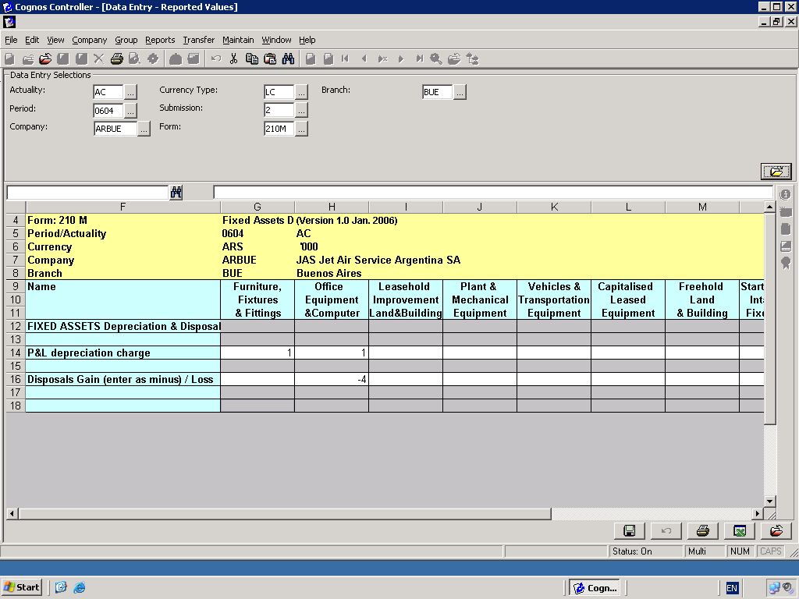

Form 211M Fixed Assets Details

Fixed Assets Furniture Fixtures & Fittings,1711OB,,,,,00000445039.91+,,,,,,,
Fixed Assets Furniture Fixtures & Fittings,1711ADD,,,,,00000143399.15+,,,,,,,
Accm. depn. Furniture Fixtures & Fittings,1712OB,,,,,00000113024.19+,,,,,,,
Accm. depn. Furniture Fixtures & Fittings,1712CYD,,,,,00000002320.85+,,,,2320.85,,,
Fixed Assets Office Equipment & Computers,1721OB,,,,,00001182839.92+,,,,,,,
Fixed Assets Office Equipment & Computers,1721DIS,,,,,00000023213.98-,,,,,,,
Accm. depn. Office Equipment & Computers,1722OB,,,,,00000421828.07+,,,,,,,
Accm. depn. Office Equipment & Computers,1722CYD,,,,,00000011512.38+,,,,88888,,,
Accm. depn. Office Equipment & Computers,1722DIS,,,,,00000005678.24-,,,,,,,
CF addition F&F finance,CF1711ADDF,,,,,00000033000.00+,,,,,,,
CF addition Office -cash,CF1711ADDC,,,,,00000110399.15+,,,,,,,
Disposal Proceeds P/EX,CF1721DISP,,,,,00000008000.00-,,,,,,,
Disposal Proceeds Cash,CF1721DISC,,,,,00000013000.00-,,,,,,,
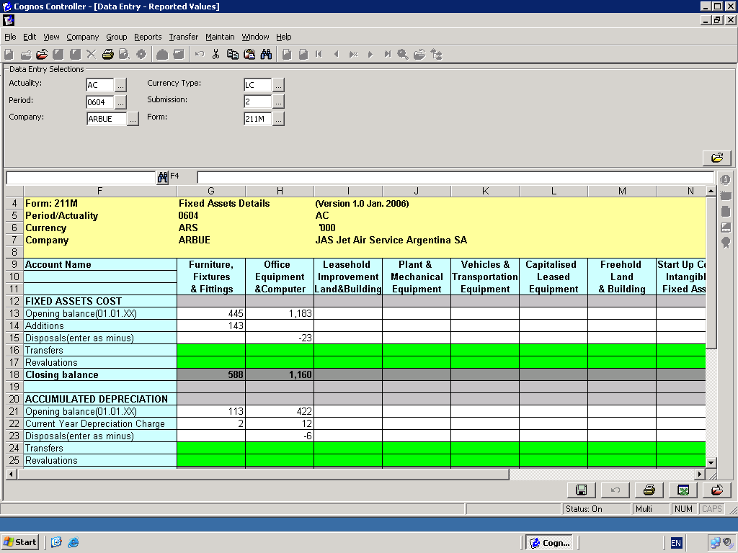

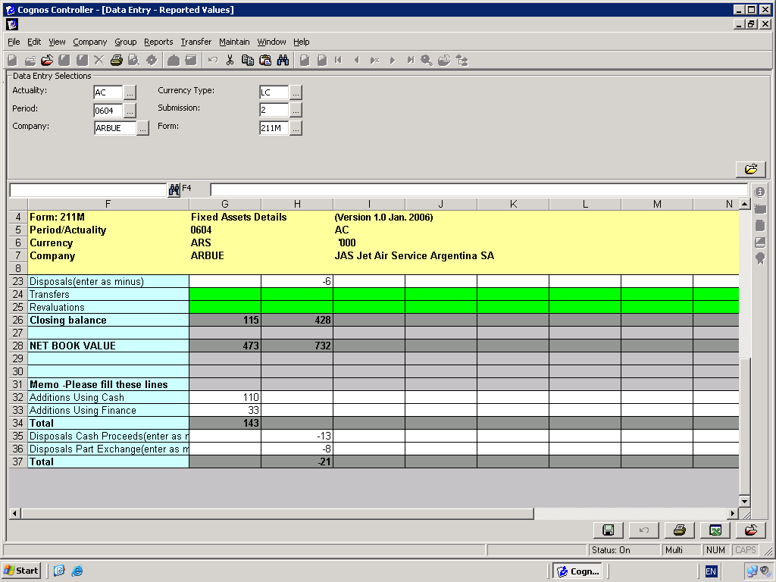

Form 220M Gross Profit by Mode – Year to Date

Turnover - 3rd Party,3010,ICTOTA,AE,BUE,,00000295764.05+
Turnover - 3rd Party,3010,ICTOTA,AI,BUE,,00000279129.35+
Turnover - 3rd Party,3010,ICTOTA,CHB,BUE,,00000307946.52+
Turnover - 3rd Party,3010,ICTOTA,ME,BUE,,00000017696.45+
Turnover - 3rd Party,3010,ICTOTA,MI,BUE,,00000231013.46+
Turnover - 3rd Party,3010,ICTOTA,NV,BUE,,00000032761.02+
Turnover - 3rd Party,3010,ICTOTA,OTH,BUE,,00000000802.16+
Turnover - 3rd Party,3010,ICTOTA,WPT,BUE,,00000007812.93+
Turnover - 3rd Party,3010,ICTOTA,WPT,BUE,,00000000607.50-

Turnover - 3rd Party,3020,ICTOTA,AE,BUE,,00000001511.53+
Turnover - 3rd Party,3020,ICTOTA,AI,BUE,,00000001155.02+
Turnover - 3rd Party,3020,ICTOTA,CHB,BUE,,00000008266.94+
Turnover - 3rd Party,3020,ICTOTA,NV,BUE,,00000000772.39+
Turnover - 3rd Party,3020,ICTOTA,WPT,BUE,,00000000607.50+

Turnover - JASWW,3040,KZALA,NV,BUE,,00000007002.53+
Turnover - JASWW,3040,AUCOR,NV,BUE,,00000052906.56+
Turnover - JASWW,3040,BRSAO,NV,BUE,,00000002592.55+
Turnover - JASWW,3040,CLSCL,AE,BUE,,00000000036.30-
Turnover - JASWW,3040,DEFRA,AE,BUE,,00000011497.55+
Turnover - JASWW,3040,DEFRA,AI,BUE,,00000000962.81+
Turnover - JASWW,3040,DEFRA,CHB,BUE,,00000002589.84+
Turnover - JASWW,3040,DEFRA,NV,BUE,,00000006888.09+
Turnover - JASWW,3040,ESBCN,NV,BUE,,00000001567.67+
Turnover - JASWW,3040,FRPAR,CHB,BUE,,00000001937.50+
Turnover - JASWW,3040,GBLON,CHB,BUE,,00000000959.36+
Turnover - JASWW,3040,GBLON,NV,BUE,,00000007678.26+
Turnover - JASWW,3040,HKHKG,NV,BUE,,00000000589.24+
Turnover - JASWW,3040,INDEL,CHB,BUE,,00000001030.00+
Turnover - JASWW,3040,ITMIL,AI,BUE,,00000002025.00+
Turnover - JASWW,3040,ITMIL,CHB,BUE,,00000008103.77+
Turnover - JASWW,3040,ITMIL,MI,BUE,,00000002777.58+
Turnover - JASWW,3040,ITMIL,NV,BUE,,00000017585.67+
Turnover - JASWW,3040,JPTYO,NV,BUE,,00000005695.48+
Turnover - JASWW,3040,MYWWM,AE,BUE,,00000000305.49-
Turnover - JASWW,3040,NLAMS,CHB,BUE,,00000000132.50+
Turnover - JASWW,3040,NZAKL,AE,BUE,,00000000520.90+
Turnover - JASWW,3040,NZAKL,AI,BUE,,00000000288.21+
Turnover - JASWW,3040,NZAKL,NV,BUE,,00000024034.53+
Turnover - JASWW,3040,PECOR,NV,BUE,,00000021468.00+
Turnover - JASWW,3040,SGSIN,AE,BUE,,00000000093.44-
Turnover - JASWW,3040,ZAJNB,MI,BUE,,00000000624.82+

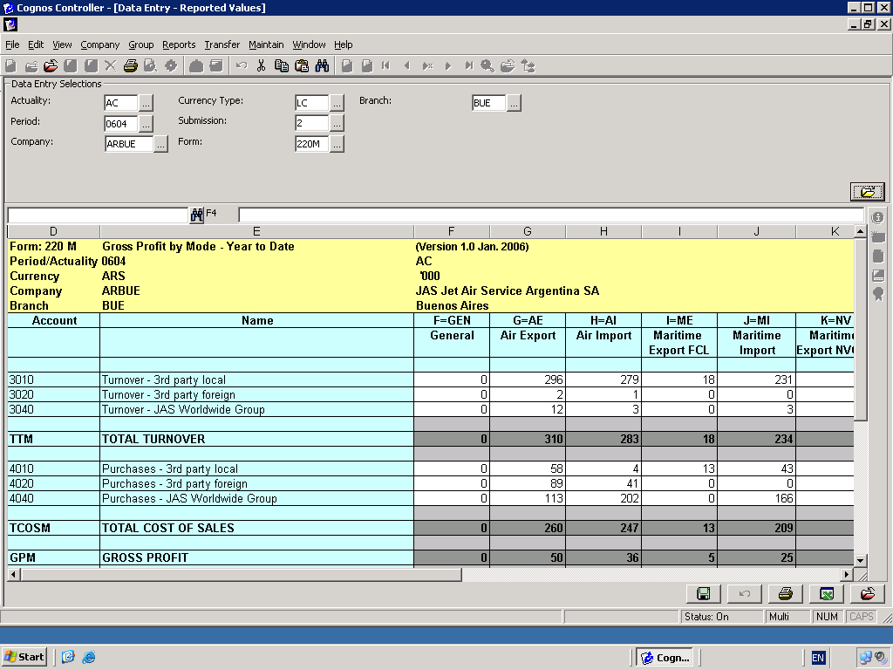

Air Export,SDIRECT,ICTOTA,AE,BUE,,00000000006.00+,,,,,,,888713.37
Air Export,SHOUSES,ICTOTA,AE,BUE,,00000000224.00+,,,,,,,
Air Import,SHOUSES,ICTOTA,AI,BUE,,00000000473.00+,,,,,,,
Customs House Brokerage,SHOUSES,ICTOTA,CHB,BUE,,00000000643.00+,,,,,,,
Maritime Export NVOCC,SHOUSES,ICTOTA,NV,BUE,,00000000052.00+,,,,,,,
Maritime Import,SHOUSES,ICTOTA,MI,BUE,,00000000096.00+
Warehousing/Packing/Trucking,SHOUSES,ICTOTA,WPT,BUE,,00000000049.00+
Warehousing/Packing/Trucking,SHOUSES,ICTOTA,WPT,BUE,,00000000028.00+
Airfreight Kilos,SKGS,ICTOTA,AE,BUE,,00000192400.00+
Airfreight Kilos,SKGS,ICTOTA,AI,BUE,,00000188855.00+
Air Export,SMASTERS,ICTOTA,AE,BUE,,00000000153.00+
Air Import,SMASTERS,ICTOTA,AI,BUE,,00000000204.00+
Maritime Export NVOCC,SMASTERS,ICTOTA,NV,BUE,,00000000045.00+
Maritime Import,SMASTERS,ICTOTA,MI,BUE,,00000000066.00+
Oceanfreight TEUs,STEU,ICTOTA,MI,BUE,,00000000201.00+,,,,,,,
Oceanfreight TEUs,STEU,ICTOTA,NV,BUE,,00000000140.00+,,,,,,,
Oceanfreight TEUs,STEU,ICTOTA,MI,COR,,00000000092.00+,,,,,,,
Oceanfreight TEUs,STEU,ICTOTA,NV,COR,,00000000026.00+,,,,,,,
Oceanfreight TEUs,STEU,ICTOTA,MI,MDZ,,00000000121.00+,,,,,,,
Oceanfreight TEUs,STEU,ICTOTA,NV,MDZ,,00000000028.00+,,,,,,,

Headcount,HCOUNT,,,BUE,,00000000074.00+
Headcount,HCOUNT,ICTOTA,,AR1,,00000000004.00+
Headcount Administration,HCOUNTADM,,GEN,BUE,,10+
Headcount sales,HCOUNTSALES,,AE,BUE,,2+
Headcount sales,HCOUNTSALES,,AI,BUE,,3+
Headcount sales,HCOUNTSALES,,CHB,BUE,,4+
Headcount sales,HCOUNTSALES,,ME,BUE,,5+
Headcount sales,HCOUNTSALES,,MI,BUE,,6+
Headcount sales,HCOUNTSALES,,NV,BUE,,7+
Headcount sales,HCOUNTSALES,,OTH,BUE,,8+
Headcount sales,HCOUNTSALES,,WPT,BUE,,9+
Headcount shipment control,HCOUNTSC,,AE,BUE,,1+
Headcount shipment control,HCOUNTSC,,AI,BUE,,2+
Headcount shipment control,HCOUNTSC,,CHB,BUE,,3+
Headcount shipment control,HCOUNTSC,,ME,BUE,,4+
Headcount shipment control,HCOUNTSC,,MI,BUE,,1+
Headcount shipment control,HCOUNTSC,,NV,BUE,,2+
Headcount shipment control,HCOUNTSC,,OTH,BUE,,3+
Headcount shipment control,HCOUNTSC,,WPT,BUE,,4+

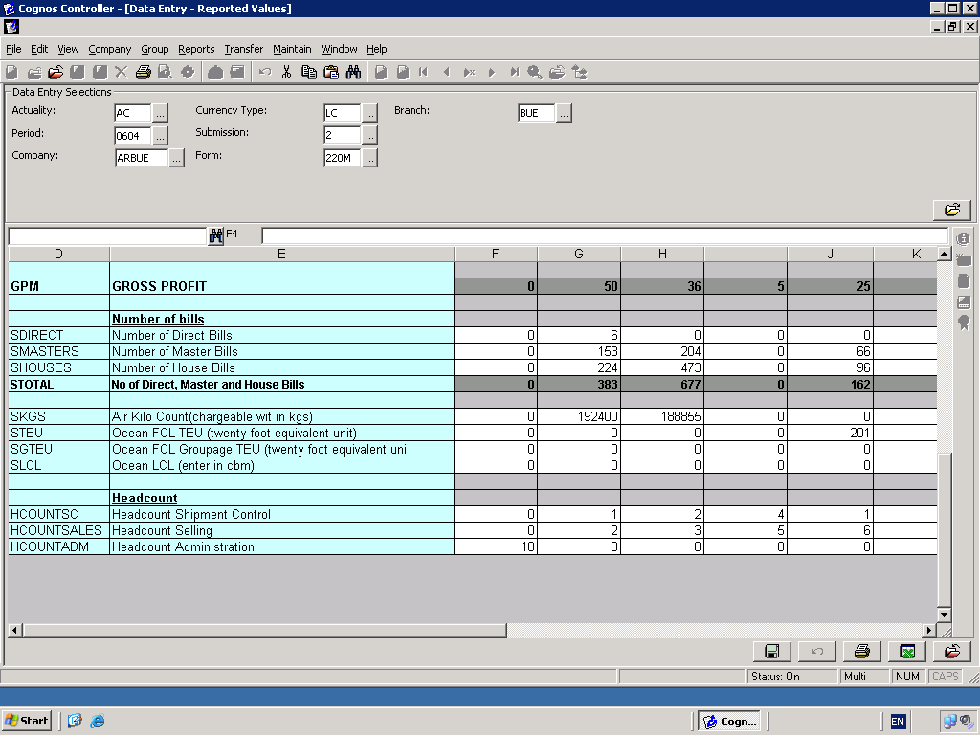

Form 221M Analysis of JASWW Group Turnover

Turnover - JAS Worldwide Group Intercompany,J3040,KZALA,GEN,BUE,,00000007102.30+,USD,00000002502.30+
Turnover - JAS Worldwide Group Intercompany,J3040,AUCOR,GEN,BUE,,00000052906.76+,USD,00000018906.76+
Turnover - JAS WW GroupInterco, J3040, BRSAO, GEN, BUE, ,00000002492.05 +,USD, 000000892.05+
Turnover - JAS WW Group Interco,J3040,CLSCL,GEN,BUE,,00000000036.30-,USD,00000000012.30-
Turnover - JAS WW Group Interco,J3040,DEFRA,GEN,BUE,,00000021638.19+,USD,00000007638.19+
Turnover - JAS WW Group Interco,J3040,ESBCN,GEN,BUE,,00000001067.37+,USD,00000000367.37+
Turnover - JAS WW Group Interco,J3040,FRPAR,GEN,BUE,,00000001937.50+,USD,00000000637.50+
Turnover - JAS WW Group Interco,J3040,GBLON,GEN,BUE,,00000008737.62+,USD,00000002737.62+
Turnover - JAS WW Group Interco,J3040,HKHKG,GEN,BUE,,00000000489.24+,USD,00000000139.24+
Turnover - JAS WW Group Interco,J3040,INDEL,GEN,BUE,,00000001030.00+,USD,0000000330.00+
Turnover - JAS WW Group Interco,J3040,ITMIL,GEN,BUE,,00000030892.32+,USD,00000010992.32+
Turnover - JAS WW Group Interco,J3040,JPTYO,GEN,BUE,,00000005895.48+,USD,00000001780.48+
Turnover -JAS WW Group Interco,J3040,MYWWM,GEN,BUE,,00000000305.49-,USD,00000000105.49-
Turnover - JAS WW Group Interco,J3040,NLAMS,GEN,BUE,,00000000132.50+,USD,00000000040.50+
Turnover - JAS WW Group Interco,J3040,NZAKL,GEN,BUE,,00000025043.94+,USD,00000008043.94+
Turnover - JAS WW Group Interco,J3040,PECOR,GEN,BUE,,00000021468.00+,USD,00000007468.00+
Turnover - JAS WW Group Interco,J3040,SGSIN,GEN,BUE,,00000000093.44-,USD,000000000939.44-
Turnover - JAS WW Group Interco,J3040,ZAJNB,GEN,BUE,,00000000624.82+,USD,00000000234.82+

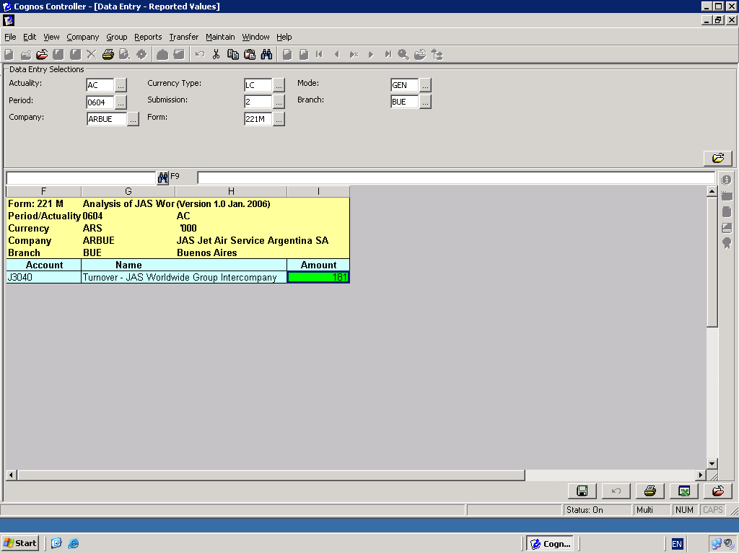

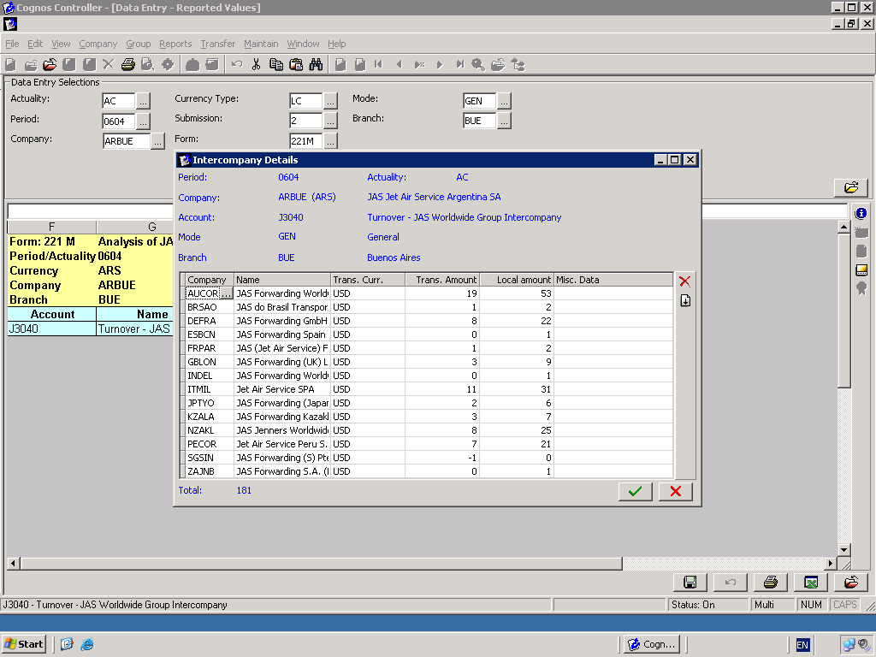

Form 222M Analysis of JASWW Group Purchases

Purchases - JAS WW Group Interco,J4040,AEFZE,GEN,BUE,,00000000952.54+,USD,00000000332.54+
Purchases - JAS WW Group Interco,J4040,KZALA,GEN,BUE,,00000009027.24+,USD,00000003027.24+
Purchases - JAS WW Group nterco,J4040,AUCOR,GEN,BUE,,00000006275.14+,AUD,00000002475.14+
Purchases - JAS WW Group Interco,J4040,BRSAO,GEN,BUE,,00000006251.43+,USD,00000003051.43+
Purchases - JAS WW Group Interco,J4040,CLSCL,GEN,BUE,,00000002941.15+,USD,00000000941.15+
Purchases - JAS WW Group Interco,J4040,CNCAN,GEN,BUE,,00000003367.25+,USD,00000001123.25+
Purchases - JAS WW Group Interco,J4040,CNDLC,GEN,BUE,,00000000136.47+,USD,00000000040.47+
Purchases - JAS WW Group Interco,J4040,CNSHA,GEN,BUE,,00000016102.40+,USD,00000005102.40+
Purchases - JAS WW Group Interco,J4040,DEFRA,GEN,BUE,,00000046658.55+,EUR,00000032658.55+
Purchases - JAS WW Group Interco,J4040,DKCOR,GEN,BUE,,00000005572.90+,USD,00000002272.90+
Purchases - JAS WW Group Interco,J4040,ESBCN,GEN,BUE,,00000023275.93+,EUR,00000008275.93+
Purchases - JAS WW Group Interco,J4040,FRPAR,GEN,BUE,,00000048274.84+,EUR,00000015274.84+
Purchases - JAS WW Group Interco,J4040,GBLON,GEN,BUE,,00000074171.43+,GBP,00000038171.43+
Purchases - JAS WW Group nterco,J4040,HKHKG,GEN,BUE,,00000009534.22+,USD,00000003534.22+
Purchases - JAS WW Group Interco,J4040,INDEL,GEN,BUE,,00000013330.26+,USD,00000003330.26+
Purchases - JAS WW Group Interco,J4040,ITMIL,GEN,BUE,,00000175516.93+,USD,0000058516.93+
Purchases - JAS WW Group Interco,J4040,JPTYO,GEN,BUE,,00000001009.64+,JPY,00000000027.64+
Purchases - JAS WW Group Interco,J4040,KRSEL,GEN,BUE,,00000005765.15+,USD,00000002400.15+
Purchases - JAS WW Group Interco,J4040,MXGDL,GEN,BUE,,00000000006.00-,USD,00000000002.00-
Purchases-JAS WW Group Interco, J4040 ,MYWWM ,GEN ,BUE, ,00000004028.97,USD,000001304.97+
Purchases - JAS WW Group Interco,J4040,NLAMS,GEN,BUE,,00000000682.44+,USD,00000000231.44+
Purchases - JAS WW Group Interco,J4040,NZAKL,GEN,BUE,,00000004307.40+,USD,00000001407.40+
Purchases - JAS WW Group Interco,J4040,PECOR,GEN,BUE,,00000000921.78+,USD,00000000321.78+
Purchases - JAS WW Group Interco,J4040,SEGOT,GEN,BUE,,00000000432.74+,USD,00000000180.74+
Purchases - JAS WW Group Interco,J4040,SGSIN,GEN,BUE,,00000003298.04+,USD,00000001098.04+
Purchases - JAS WW Group Interco,J4040,THBKK,GEN,BUE,,00000007376.98+,USD,00000002476.98+
Purchases - JAS WW Group Interco,J4040,TRATF,GEN,BUE,,00000007080.00+,USD,00000002380.00+
Purchases - JAS WW Group Interco,J4040,TWTPE,GEN,BUE,,00000007655.56+,USD,00000002955.56+
Purchases - JAS WW Group Interco,J4040,ZAJNB,GEN,BUE,,00000016714.82+,USD,00000005714.82+

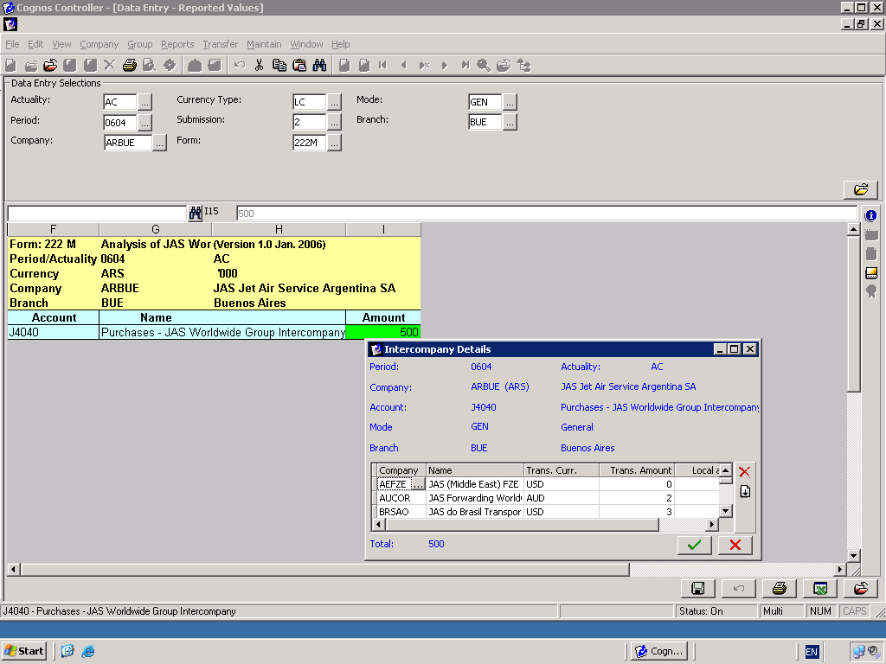

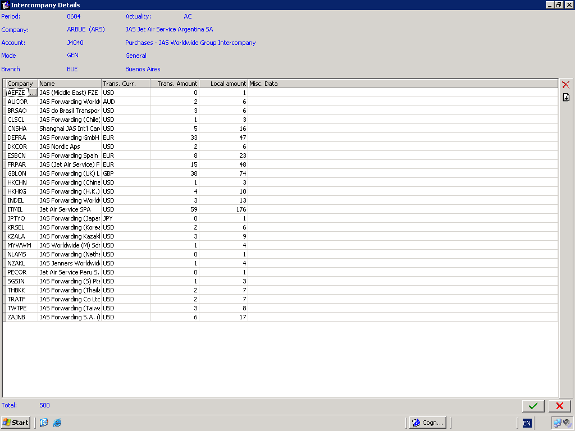

Form 230M Profit and Loss Account

Staff costs,5000,,,BUE,,00000134893.96+
Staff costs,5000,,,BUE,,00000000159.75-
Property/utilities/office supplies,6100,,,BUE,,00000051118.78+
Communications,6200,,,BUE,,00000005249.65+
Travel & transportation,6300,,,BUE,,00000002730.90+
Marketing,6400,,,BUE,,00000001209.93+
Other Overhead Costs,6900,,,BUE,,00000000072.36+
Management Charges - JAS Worldwide Group,7440,CHSVC,,AR1,,00000065647.00+
Foreign exchange - realized,8250,,,BUE,,00000006097.33-
Interest expense – JASWW Group - short term,8440,JASWW,,BUE,,00000002185.51+
Bad/doubtful debt provision,8510,,,BUE,,00000001667.00+
Depreciation - Furniture Fixtures & Fittings,8712,,,BUE,,00000000813.13+
Depreciation - Office Equipment & Computers,8722,,,BUE,,00000000950.33+
Miscellaneous Costs/Income,9100,,,BUE,,00000000978.76+
Tax charge,9500,,,BUE,,00000003638.07+
Headcount,HCOUNT,,,BUE,,00000000074.00+
TOTAL INVOICED,TI,ICTOTA,,BUE,,00001579627.74+,,,

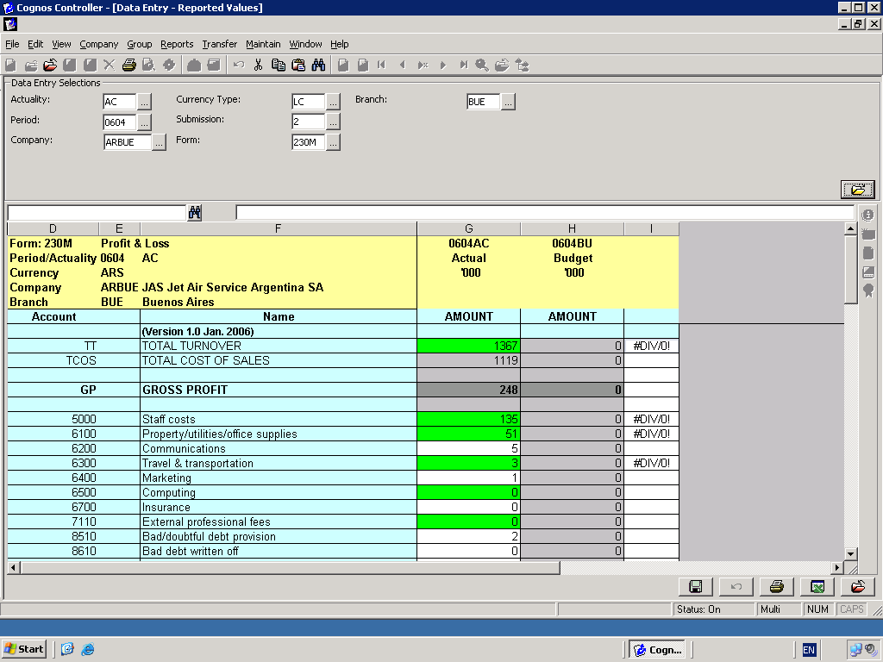

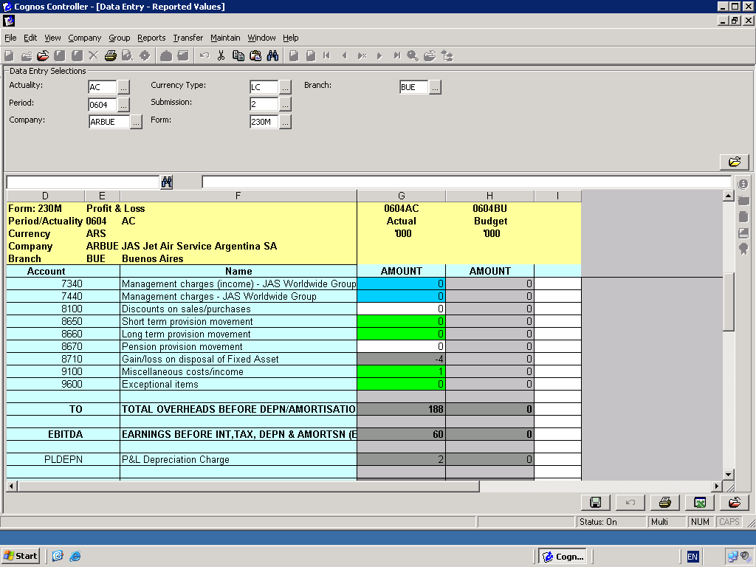

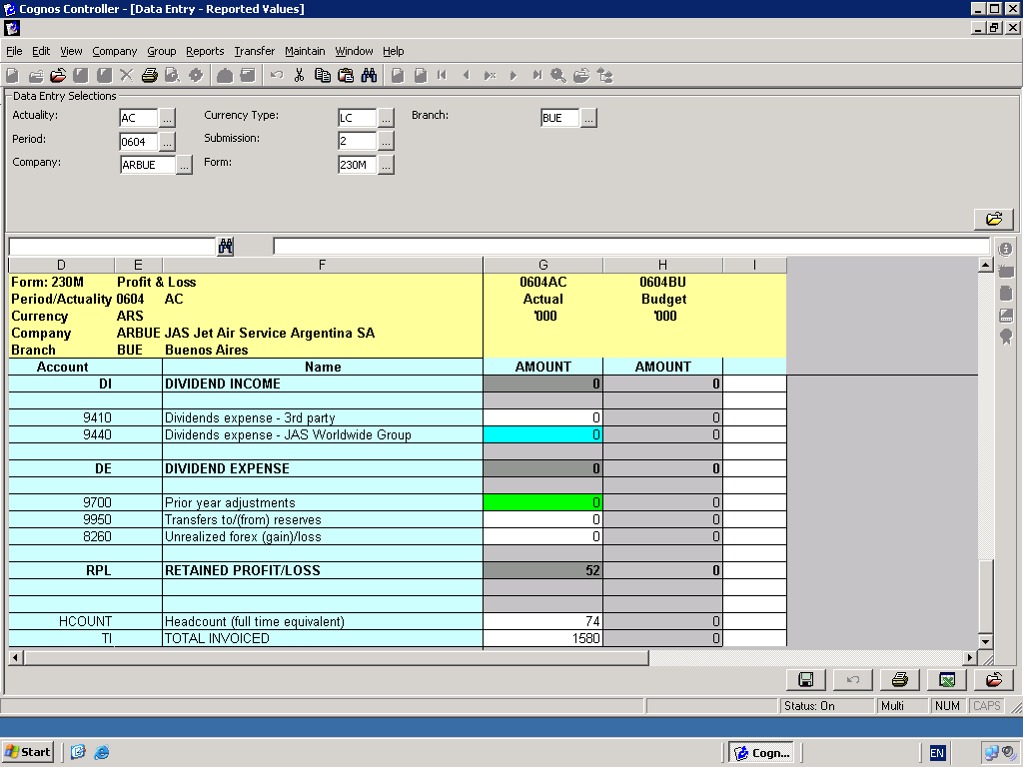

Form 230M Profit and Loss Account – account 7440 management charge

Management Charges - JAS Worldwide Group,7440,CHSVC,,AR1,,00000065647.00+

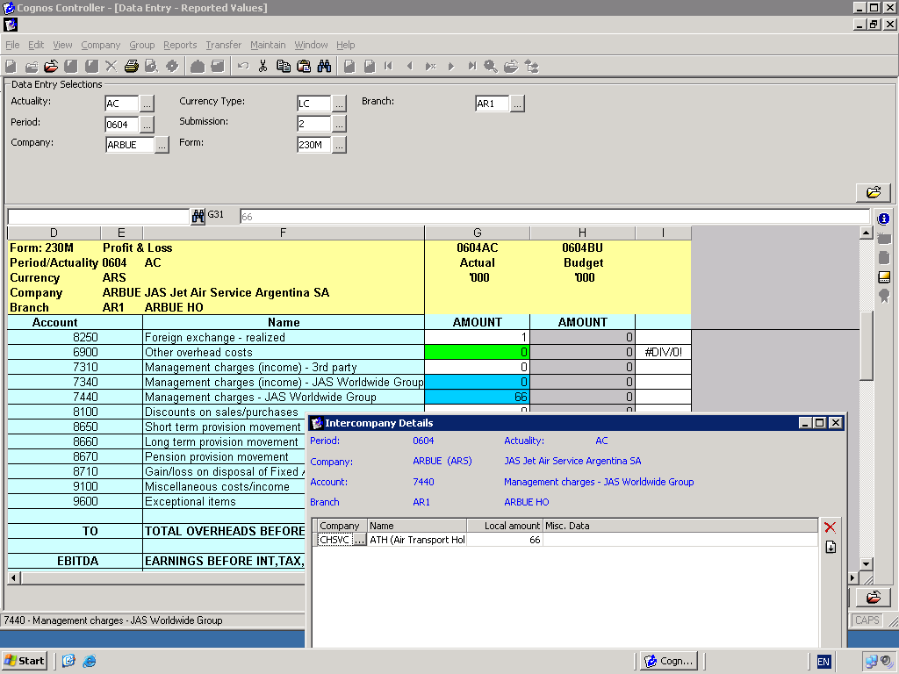

Form 230M Profit and Loss Account – account 8440- interest expense

Interest expense - jasww group - short term,8440,JASWW,,BUE,,00000002185.51+

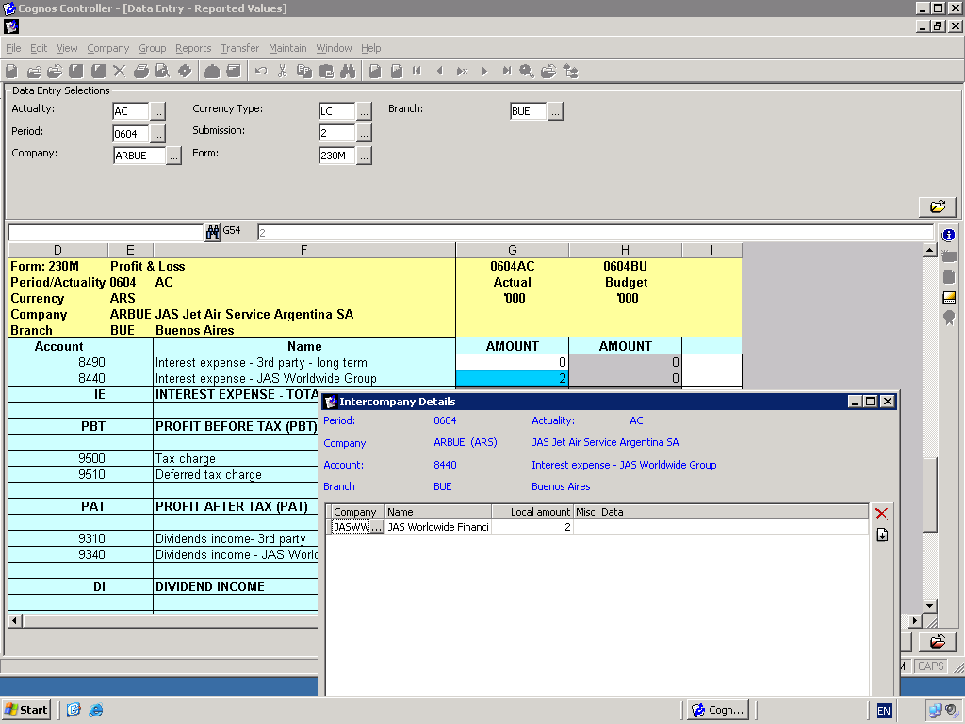

Form 240M Reserve Movements – Year to Date

Share Capital,2910OB,,,,,00012832322.05+
CF OB Ordinary Shares Issued Fully Paid,CF2910OBFP,,,,,00012000000.0+
CF OB Ordinary Shares Issued Not Paid,CF2910OBNP,,,,,00000832322.05+
Share Premium,2920OB,,,,,00000100000.00+
CF OB Share Premium Issued Fully Paid,CF2920OBFP,,,,,00000100000.00+
CF OB Share Premium Issued Not Paid,CF2920OBNP,,,,,0+
Revaluation Reserve,2930OB,,,,,00000010000.00+
Legal Reserves,2940OB,,,,,00000005000.00+
Profit & Loss Reserve,2950OB,,,,,00010046412.81+

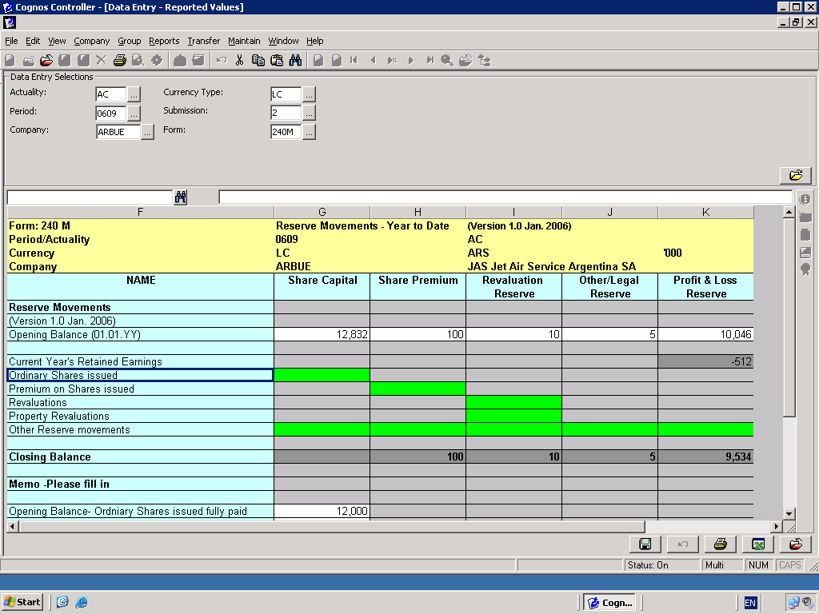

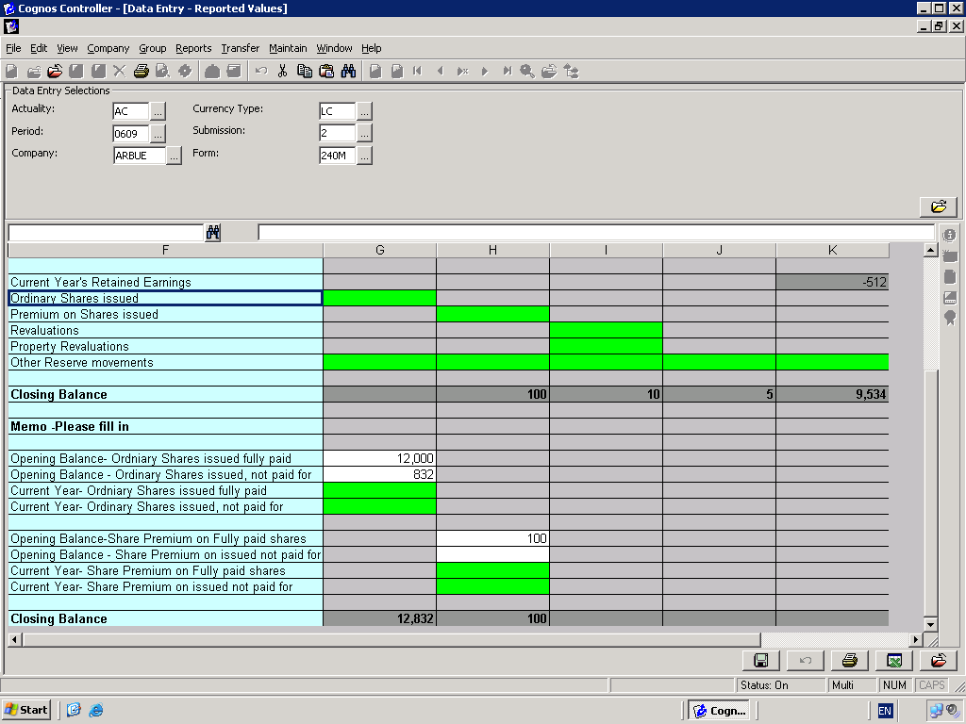

Form 250M Balance Sheet

Cash at bank & In hand,1100,,,,,00001305723.34+,,,
Cash at bank & In hand,1100,,,,,00000020000.00+,,,
Cash at bank & In hand,1100,,,,,00000010000.00+,,,
Trade Debtors,1210,,,,,00002796085.04+,,
Trade Debtors 3rd Party Aged 0-30 days,1211,,,,,00002000000.04+,,
Trade Debtors 3rd party Aged 31-60 days,1212,,,,,00000790000.04+,,
Trade Debtors 3rd Party Aged 61-90 days,1213,,,,,00000006085.04+,,
Trade Debtors-3rd Party Foreign,1220,,,,,00000541623.49+,,
Trade Debtors - JAS Worldwide Group,1241,ZAJNB,,,,00000009996.79+,USD,00000003336.79+
Trade debtors Group,1241REC,,,,,00002532579.91+,,
Other debtors,1290,,,,,00000088416.37+,,
Deposits and prepayments,1310,,,,,00001915957.38+,,
Deferred Tax Assets,1680,,,,,00000033577.84+,,
Overdrafts/Short Term Bank Finance,2100,,,,,00000235089.15-,,
Short Term Bank Financing,2120,,,,,00000560000.00-,,
Trade Creditors,2210,,,,,00003251321.60-,,
Trade Creditors-3rd Party Foreign,2220,,,,,00000372289.54-,,
Trade Creditor _JASWW Group,2241REC,,,,,00007568947.90-,,
Other creditors,2290,,,,,00000440608.52-,,
Accruals-3rd party-traffic,2410,,,,,00000081307.18-,,
Accruals-traffic-JASWW group,2440,FRPAR,,,,00000001155.02-,,
Accruals-traffic-JASWW group,2440,GBLON,,,,00000008266.94-
Accruals-traffic-JASWW group,2440,HKHKG,,,,00000000772.39-
Accruals-traffic-JASWW group,2440,HUBUD,,,,00000000607.50-
Accruals-traffic-JASWW group,2440,MXGDL,,,,00000000066.63-
Accruals-traffic-JASWW group,2440,THBKK,,,,00000000590.56-
Accruals-traffic-JASWW group,2440,VECCS,,,,00000006203.03-
Accruals-traffic-JASWW group,2440,ZAJNB,,,,00000007002.53-
Accruals - non traffic (overheads),2510,,,,,00001863980.55-
Accruals - taxes(inc corporation payroll & other),2550,,,,,00000015799.61-
Tax Charge,2552,,,,,00000005000.00-
Tax Charge,2556,,,,,00000006800.00-
Bad/doubtful debt provision,2610,,,,,00000334141.71-
Deferred Tax Liabilities,2680,,,,,00000228376.00-
Long term bank finance HP & finance leases,2700,,,,,00001341634.70-
Finance Leases,2720,,,,,00000115910.51-
Loan debtors -JAS Worldwide Group,1340,UYFSA,,,,28627000+
Loan creditors -JAS Worldwide Group,2340,CHSVC,,,,0150000.00-

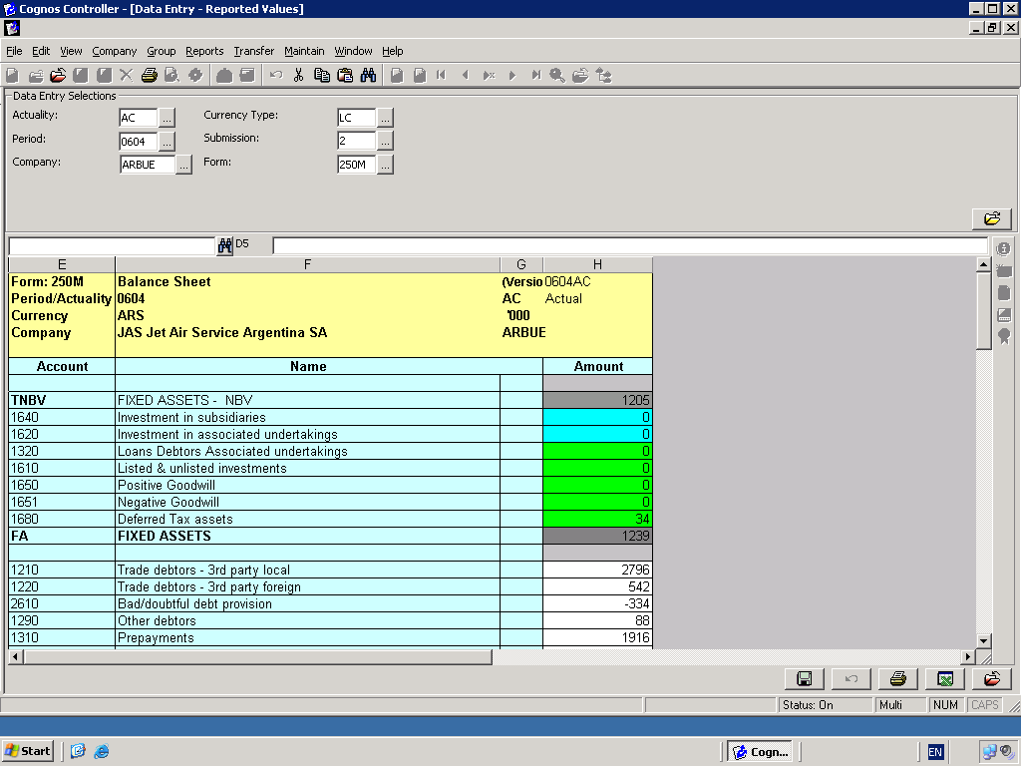

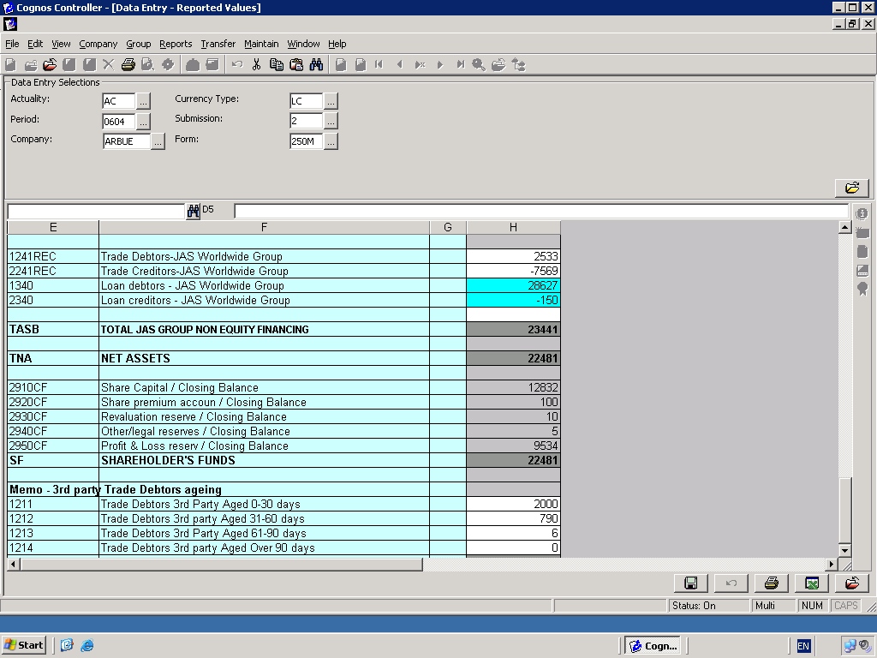

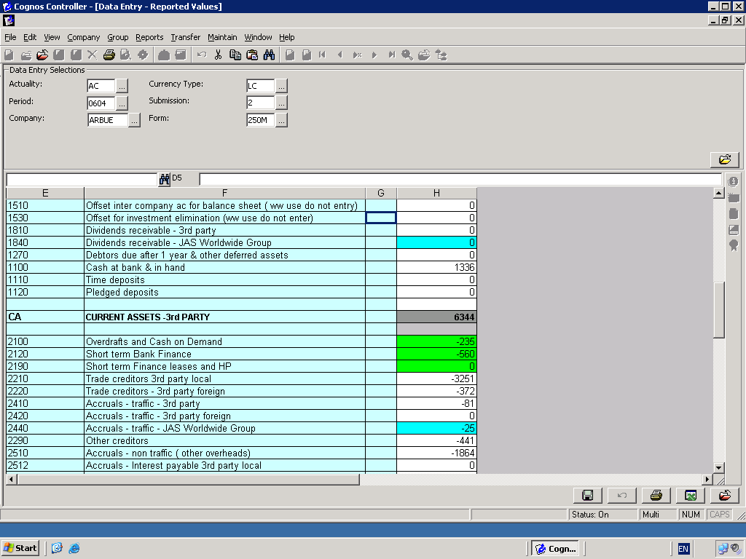

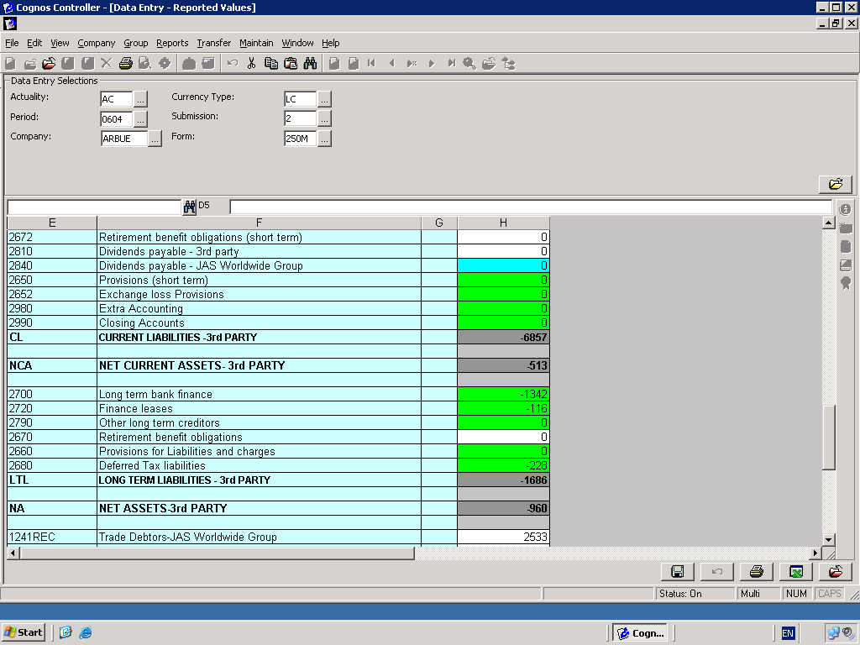

Form 250M Balance Sheet –account 2440 Traffic Accruals

Accruals-traffic-JASWW group,2440,FRPAR,,,,00000001155.02-,,
Accruals-traffic-JASWW group,2440,GBLON,,,,00000008266.94-
Accruals-traffic-JASWW group,2440,HKHKG,,,,00000000772.39-
Accruals-traffic-JASWW group,2440,HUBUD,,,,00000000607.50-
Accruals-traffic-JASWW group,2440,MXGDL,,,,00000000066.63-
Accruals-traffic-JASWW group,2440,THBKK,,,,00000000590.56-
Accruals-traffic-JASWW group,2440,VECCS,,,,00000006203.03-
Accruals-traffic-JASWW group,2440,ZAJNB,,,,00000007002.53-

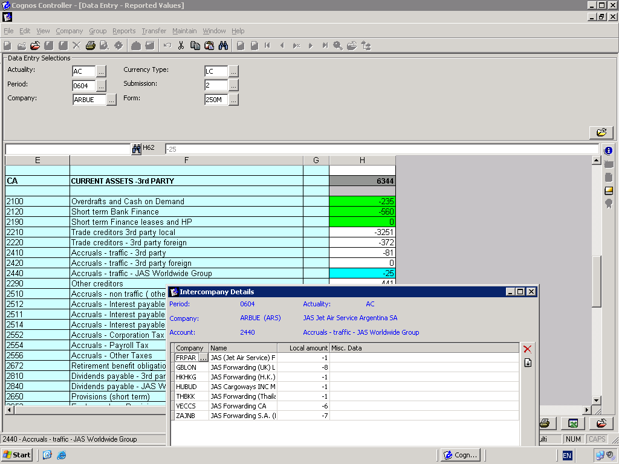

Form 250M Loan Debtors JAS Worldwide Group - account 1340

To illustrate a loan debtor of 28627000.00 with UYFSA this would be included in csv file as follows:
Loan debtors -JAS Worldwide Group,1340,UYFSA,,,,28627000.00+

As this is not a trade debtor the amount is likely to be recorded in a nominal ledger account code

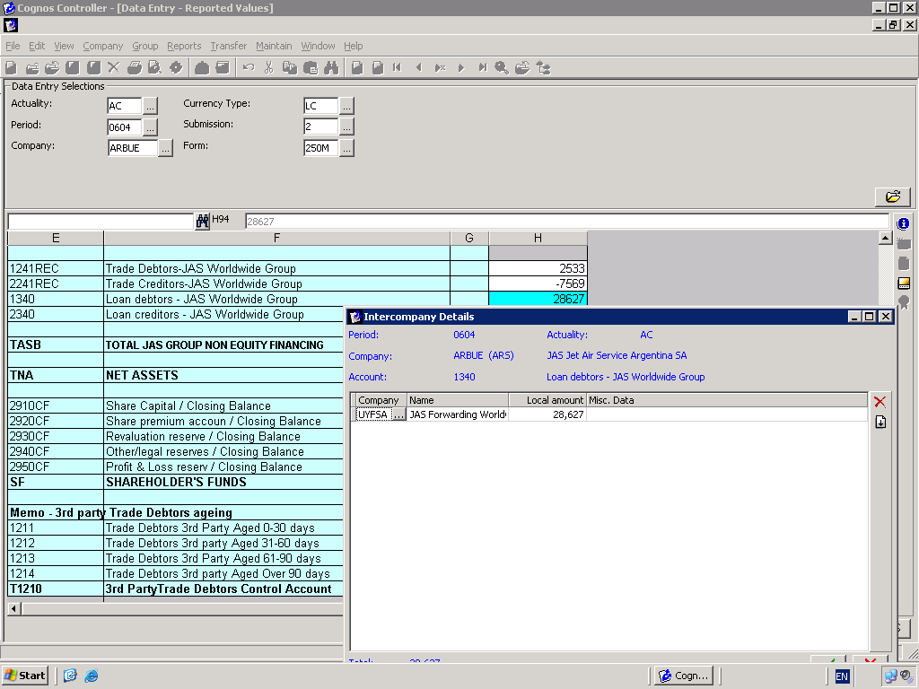

Form 250M Loan Creditors JAS Worldwide Group - account 2340

To illustrate a loan creditor balance of 150000.00 with CHSVC this would be included in csv file as follows:
Loan creditors -JAS Worldwide Group,2340,CHSVC,,,,0150000.00-

As this is not a trade creditor the amount is likely to be recorded in a nominal ledger account code.

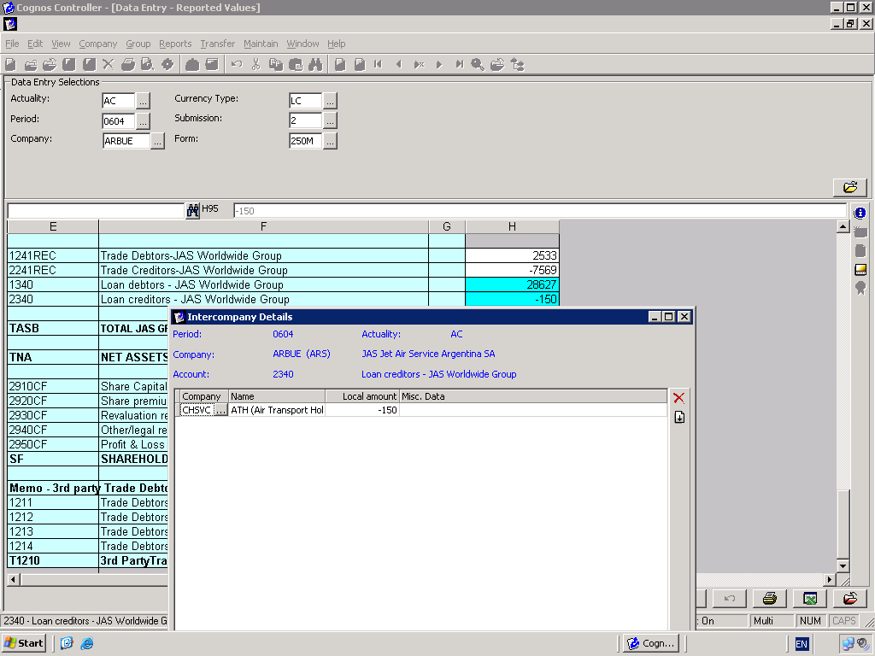

Form ICAR Intercompany Trade Debtors

Trade Debtors - JAS Worldwide Group,1241,AEFZE,,,,00000043731.08+,USD,00000010345.06+
Trade Debtors - JAS Worldwide Group,1241,KZALA,,,,00000106861.00+,USD,00000033861.00+
Trade Debtors - JAS Worldwide Group,1241,AUCOR,,,,00000094710.70+,USD,00000032610.70+
Trade Debtors - JAS Worldwide Group,1241,BRSAO,,,,00000367626.32+,USD,00000123726.32+
Trade Debtors - JAS Worldwide Group,1241,CLSCL,,,,00000045987.37+,USD,00000015687.37+
Trade Debtors - JAS Worldwide Group,1241,CNBJS,,,,00000024594.09+,USD,00000008254.09+
Trade Debtors - JAS Worldwide Group,1241,CNCAN,,,,00000018666.74+,USD,00000006666.74+
Trade Debtors - JAS Worldwide Group,1241,CNNGB,,,,00000001844.94+,USD,00000000644.94+
Trade Debtors - JAS Worldwide Group,1241,CNSHA,,,,00000160285.49+,USD,00000050285.49+
Trade Debtors - JAS Worldwide Group,1241,CNSZX,,,,00000018310.24+,USD,00000006310.24+
Trade Debtors - JAS Worldwide Group,1241,CNTAO,,,,00000000000.00+,USD,00000000000.00+
Trade Debtors - JAS Worldwide Group,1241,CNXMN,,,,00000000025.00-,USD,00000000008.00-
Trade Debtors - JAS Worldwide Group,1241,CZPRG,,,,00000015407.35+,USD,00000005407.35+
Trade Debtors - JAS Worldwide Group,1241,DEFRA,,,,00000069185.93+,USD,00000023185.93+
Trade Debtors - JAS Worldwide Group,1241,DKCOR,,,,00000005174.85+,USD,00000001740.85+
Trade Debtors - JAS Worldwide Group,1241,ECUIO,,,,00000142321.09+,USD,00000034321.09+
Trade Debtors - JAS Worldwide Group,1241,ESBCN,,,,00000022789.71+,USD,00000007789.71+
Trade Debtors - JAS Worldwide Group,1241,FRPAR,,,,00000080821.65+,USD,00000027821.65+
Trade Debtors - JAS Worldwide Group,1241,GBLON,,,,00000104949.46+,USD,00000034949.46+
Trade Debtors - JAS Worldwide Group,1241,HKHKG,,,,00000219364.08+,USD,00000071364.08+
Trade Debtors - JAS Worldwide Group,1241,HUBUD,,,,00000014693.88+,USD,00000004693.88+
Trade Debtors - JAS Worldwide Group,1241,INDEL,,,,00000013846.59+,USD,00000004846.59+
Trade Debtors - JAS Worldwide Group,1241,ITMIL,,,,00000347034.67+,USD,00000123034.67+
Trade Debtors - JAS Worldwide Group,1241,JPTYO,,,,00000019637.54+,USD,00000006637.54+
Trade Debtors - JAS Worldwide Group,1241,KRSEL,,,,00000014990.66+,USD,00000004990.66+
Trade Debtors - JAS Worldwide Group,1241,MXGDL,,,,00000016635.49+,USD,00000005635.49+
Trade Debtors - JAS Worldwide Group,1241,MYWWM,,,,00000002275.80+,USD,00000000754.80+
Trade Debtors - JAS Worldwide Group,1241,NLAMS,,,,00000014130.09+,USD,00000004130.09+
Trade Debtors - JAS Worldwide Group,1241,NZAKL,,,,00000087649.34+,USD,00000023649.34+
Trade Debtors - JAS Worldwide Group,1241,PECOR,,,,00000100319.52+,USD,00000033319.52+
Trade Debtors - JAS Worldwide Group,1241,SEGOT,,,,00000273060.23+,USD,00000093060.23+
Trade Debtors - JAS Worldwide Group,1241,SGSIN,,,,00000021373.91+,USD,00000007373.91+
Trade Debtors - JAS Worldwide Group,1241,THBKK,,,,00000000082.01-,USD,00000000023.01-
Trade Debtors - JAS Worldwide Group,1241,TWTPE,,,,00000007876.57+,USD,00000002576.57+
Trade Debtors - JAS Worldwide Group,1241,UYFSA,,,,00000039240.32+,USD,00000013240.32+
Trade Debtors - JAS Worldwide Group,1241,VECCS,,,,00000007293.43+,USD,00000002793.43+
Trade Debtors - JAS Worldwide Group,1241,ZAJNB,,,,00000009996.79+,USD,00000003336.79+

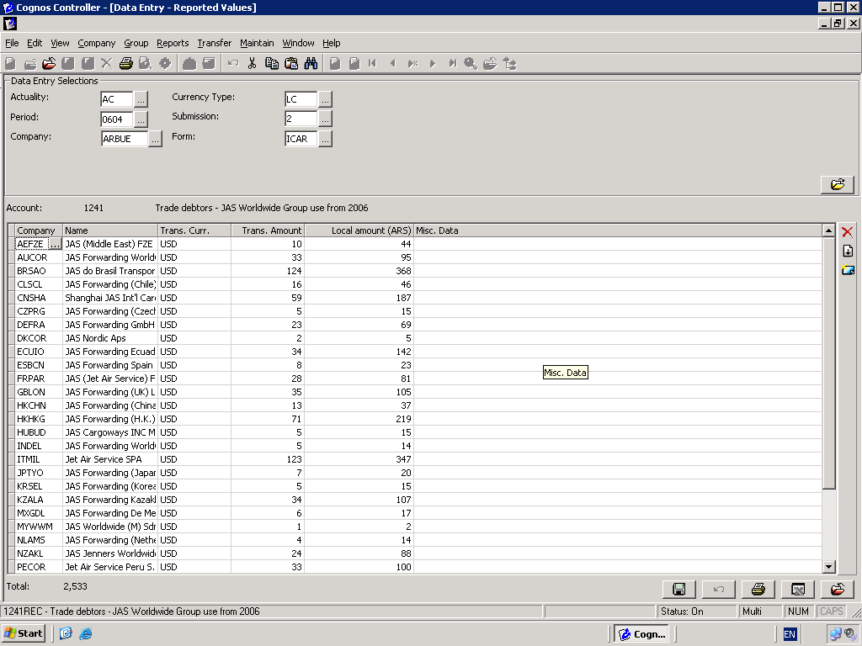

Form ICAP Intercompany Trade Creditors

Trade Creditors - JAS Worldwide Group,2241,AEFZE,,,,00000024738.50-,AED,00000031738.50-
Trade Creditors - JAS Worldwide Group,2241,KZALA,,,,00000036492.06-,USD,00000012492.06-
Trade Creditors - JAS Worldwide Group,2241,AUCOR,,,,00000020925.53-,AUD,00000008925.53-
Trade Creditors - JAS Worldwide Group,2241,BRSAO,,,,00000260782.93-,USD,00000080782.93-
Trade Creditors - JAS Worldwide Group,2241,CHJAS,,,,00000031946.13-,USD,00000010946.13-
Trade Creditors - JAS Worldwide Group,2241,CLSCL,,,,00000116340.27-,USD,00000356340.27-
Trade Creditors - JAS Worldwide Group,2241,CNBJS,,,,00000010829.72-,USD,00000003829.72-
Trade Creditors - JAS Worldwide Group,2241,CNCAN,,,,00000071411.44-,USD,00000024411.44-
Trade Creditors - JAS Worldwide Group,2241,CNDLC,,,,00000001097.46-,USD,00000000397.46-
Trade Creditors - JAS Worldwide Group,2241,CNNGB,,,,00000052340.03-,USD,00000016340.03-
Trade Creditors - JAS Worldwide Group,2241,CNSHA,,,,00000910615.52-,USD,00000301615.52-
Trade Creditors - JAS Worldwide Group,2241,CNSZX,,,,00000343353.21-,USD,00000118353.21-
Trade Creditors - JAS Worldwide Group,2241,CNTAO,,,,00000041841.82-,USD,00000014841.82-
Trade Creditors - JAS Worldwide Group,2241,CNTSN,,,,00000030061.44-,USD,00000010061.44-
Trade Creditors - JAS Worldwide Group,2241,CNXMN,,,,00000029835.60-,USD,00000009835.60-
Trade Creditors - JAS Worldwide Group,2241,CZPRG,,,,00000001296.40-,USD,00000000596.40-
Trade Creditors - JAS Worldwide Group,2241,DEFRA,,,,00000341945.43-,USD,00000142945.43-
Trade Creditors - JAS Worldwide Group,2241,DKCOR,,,,00000004187.61-,DKK,00000002787.61-
Trade Creditors - JAS Worldwide Group,2241,ECUIO,,,,00000059366.54-,USD,00000199366.54-
Trade Creditors - JAS Worldwide Group,2241,ESBCN,,,,00000152554.56-,EUR,00000042554.56-
Trade Creditors - JAS Worldwide Group,2241,FRPAR,,,,00000099365.19-,EUR,00000030365.19-
Trade Creditors - JAS Worldwide Group,2241,GBLON,,,,00000151333.65-,GBP,00000036133.65-
Trade Creditors - JAS Worldwide Group,2241,HKHKG,,,,00000664764.59-,HKD,00000254764.59-
Trade Creditors - JAS Worldwide Group,2241,HUBUD,,,,00000013483.88-,USD,00000043483.88-
Trade Creditors - JAS Worldwide Group,2241,INDEL,,,,00000235680.13-,USD,00000800680.13-
Trade Creditors - JAS Worldwide Group,2241,ITMIL,,,,00002523997.90-,EUR,00001000997.90-
Trade Creditors - JAS Worldwide Group,2241,JPTYO,,,,00000105986.41-,JPY,00000020946.41-
Trade Creditors - JAS Worldwide Group,2241,KRSEL,,,,00000182221.82-,USD,00000062221.82-
Trade Creditors - JAS Worldwide Group,2241,MXGDL,,,,00000034335.17-,USD,00000034335.17-
Trade Creditors - JAS Worldwide Group,2241,MYKUL,,,,00000002592.14-,USD,00000000892.14-
Trade Creditors - JAS Worldwide Group,2241,MYWWM,,,,00000004384.49-,USD,00000001384.49-
Trade Creditors - JAS Worldwide Group,2241,NLAMS,,,,00000094024.17-,USD,00000032024.17-
Trade Creditors - JAS Worldwide Group,2241,NZAKL,,,,00000024989.62-,USD,00000008989.62-
Trade Creditors - JAS Worldwide Group,2241,PECOR,,,,00000029378.44-,USD,00000009378.44-
Trade Creditors - JAS Worldwide Group,2241,SEGOT,,,,00000125027.51-,USD,00000081027.51-
Trade Creditors - JAS Worldwide Group,2241,SGSIN,,,,00000129887.78-,USD,00000040887.78-
Trade Creditors - JAS Worldwide Group,2241,THBKK,,,,00000066856.48-,USD,00000022856.48-
Trade Creditors - JAS Worldwide Group,2241,TRATF,,,,00000024866.00-,USD,00000008696.00-
Trade Creditors - JAS Worldwide Group,2241,TWTPE,,,,00000488861.18-,USD,00000168181.18-
Trade Creditors - JAS Worldwide Group,2241,UYFSA,,,,00000001792.47-,USD,00000000692.47-
Trade Creditors - JAS Worldwide Group,2241,VECCS,,,,00000003625.00-,USD,00000001225.00-
Trade Creditors - JAS Worldwide Group,2241,ZAJNB,,,,00000019531.68-,USD,00000006531.68-

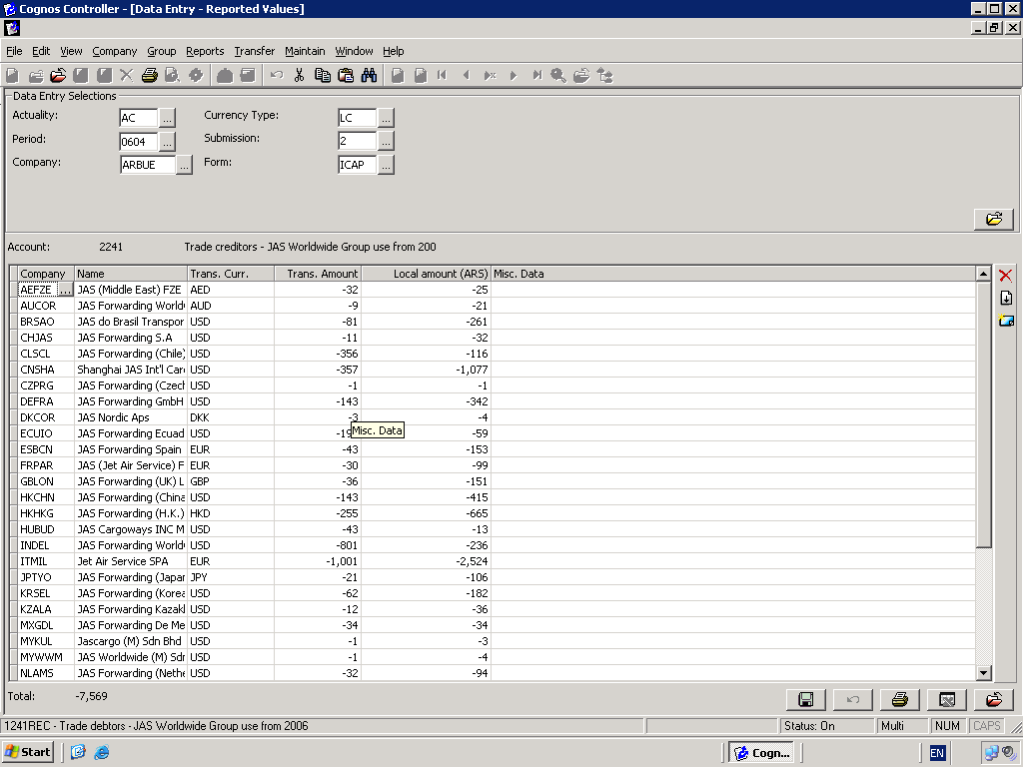

Form SEG Segment Report

Turnover Analysis by SEG -Local,3010SEG,ICTOTA,,,CHM,00000382608.85+,,,SAM
Turnover Analysis by SEG -Local,3010SEG,ICTOTA,,,FOD,00000007562.89+,,,SAM
Turnover Analysis by SEG -Local,3010SEG,ICTOTA,,,OTR,00000502520.90+,,,SAM
Turnover Analysis by SEG -Local,3010SEG,ICTOTA,,,MOT,00000517553.58+,,,SAM
Turnover Analysis by SEG -Local,3010SEG,ICTOTA,,,PER,00000279129.35+,,,SAM
Turnover Analysis by SEG -Local,3010SEG,ICTOTA,,,TEL,00000272041.63+,,,SAM
Turnover Analysis by SEG -Local,3010SEG,ICTOTA,,,TEX,000000063562.35+,,,SAM
Turnover Analysis by SEG -Foreign,3020SEG,ICTOTA,,,CHM,00000000607.50+,,,MEA
Turnover Analysis by SEG -Foreign,3020SEG,ICTOTA,,,CHM,00000006203.03+,,,SAM
Turnover Analysis by SEG -Foreign,3020SEG,ICTOTA,,,OTR,00000001155.02+,,,NAM
Turnover Analysis by SEG -Foreign,3020SEG,ICTOTA,,,PER,00000000066.63+,,,ANZ
Turnover Analysis by SEG -Foreign,3020SEG,ICTOTA,,,MOT,00000000590.56+,,,FEA
Turnover Analysis by SEG -Foreign,3020SEG,ICTOTA,,,TEL,00000008266.94+,,,EUR
Turnover Analysis by SEG -Foreign,3020SEG,ICTOTA,,,FOD,00000000772.39+,,,AFR
Turnover Analysis by SEG -Foreign,3020SEG,ICTOTA,,,TEX,00000001511.53+,,,SEA

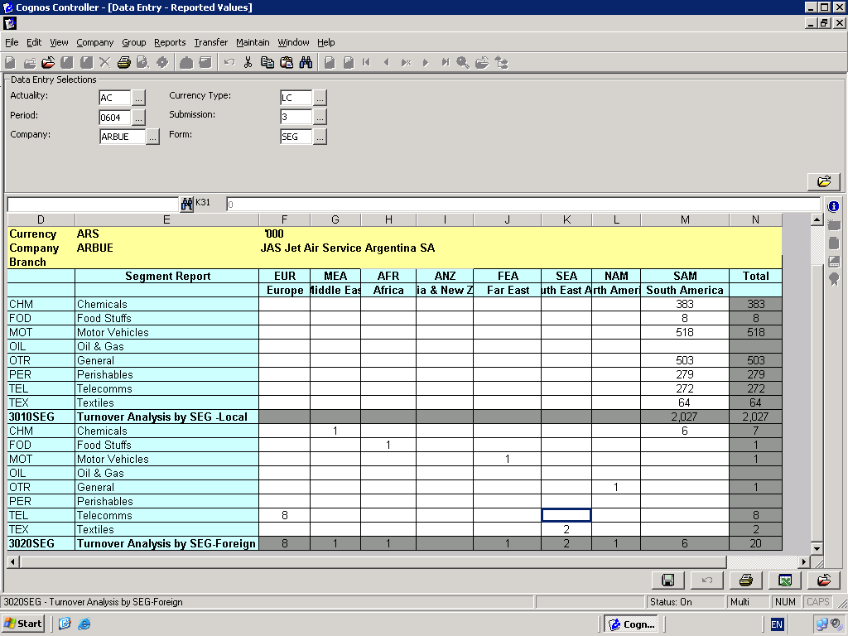

Section 8: Other documents for reference

0604ARBUEac.csv
The sample csv file for period 0604 (ie year to date figures to April 2006 for an example company ARBUE with 5 branches including a head office branch)
Some notes are included in this file outside range of file details that are imported. A header line is also included which is not required for import of .csv file.

Cognos Controller Interface- Codes signage dimensions V1.0
This shows Controller codes ,signage of the account, mode, branch, business segment, geographical region, intercompany requirements, which are included in all input forms as at 01 March 2006..

Input Forms with accounts showing signage.
These shows Controller codes and signage for accounts which are included in Controller input forms as at 01 March 2006

Section 9: Developments to be borne in mind

Interfaces created in your office to extract the require data should be designed to take into account:

New Controller codes
Usually a number of new account codes are created within Controller Chart of Accounts during the course of a year. Any necessary configuration in local accounting and or traffic systems should be flexible to allow new codes to be created without the necessity to make modifications to extraction program used to generate the csv file.

Local Ledger codes
Any new codes in your local accounts must be ‘mapped’ to Controller codes and included in the data extracted in the csv file.

Local ledger fixed asset codes
By having separate COST accounts for Opening Balance, Additions, Disposals and separate ACCUMULATION DEPRECIATION accounts for Opening Balance, Current year to date depreciation and disposals this extraction of amounts to populate Fixed Assets form 211will be simplified. Hence, you may need to open up this in your local system.

Period 13
This additional period is where final results are provided at year end. Period 12 will be used to collect draft figures. A csv file must be created for period 13, which will be the final audited results

Section 10: Intercompany Accounts A,I,J clarification only
Intercompany accounts are used in Group Consolidation to eliminate transaction between Group Companies. Cognos has pre-defined internal codes type enabling Cognos to perform these tasks.
Codes I, J require different levels of information to be provided.
Note, these internal codes are different from an account code may or may not have included I or J, to help highlight the background work undertaken by Cognos.

I type codes
Example: I code. These require Counter Company and Amount in Local Currency.
(An account may have extended dimensions as indicated in example below by 1 in ‘branch’)

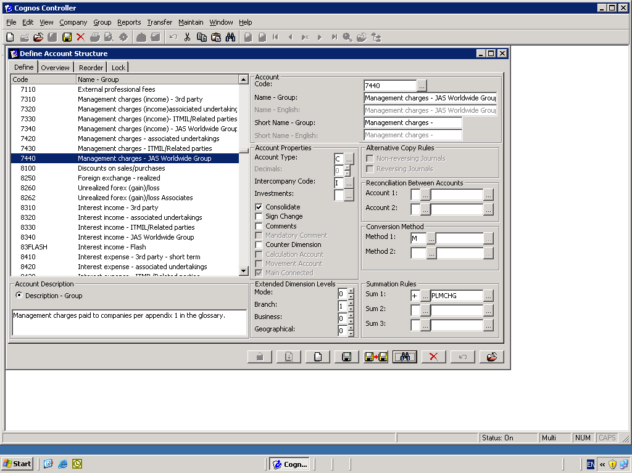

Management Charges - JAS Worldwide Group,7440,CHSVC,,AR1,,00000065647.00+

J type codes
These codes require Counter Company, Transaction Currency, Transaction Amount and Amount in local currency
(An account may have extended dimensions, but not indicated in example below as mode,branch,business,segment are showing 0)

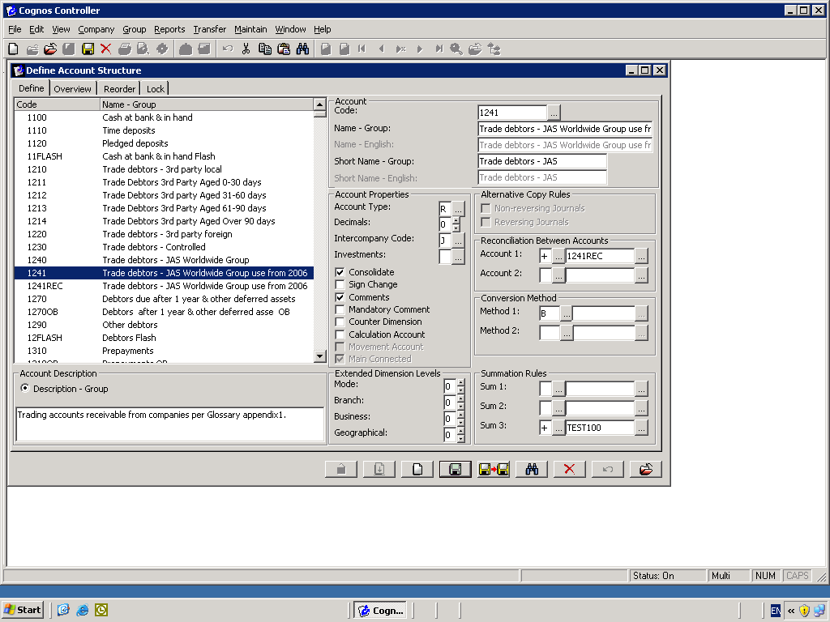

Trade Creditors - JAS Worldwide Group,2241,AEFZE,,,,00000024738.50-,AED,00000031738.50-

A type codes

These are used by Cognos to do internal conversation for shareholdings.

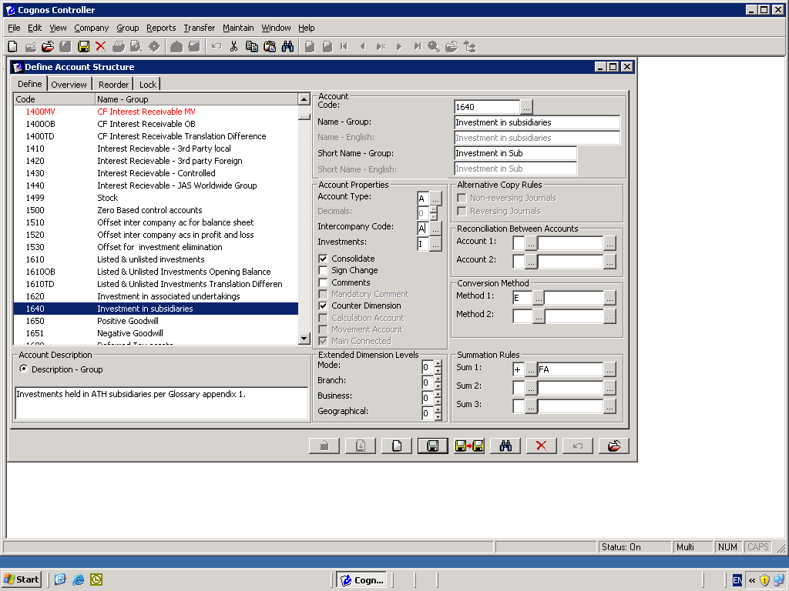

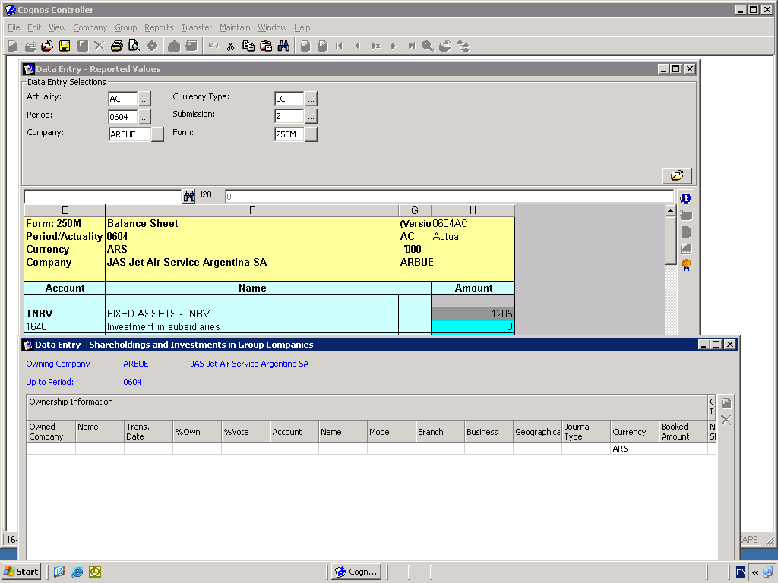

Glossary

Term | Description
Cognos CONTROLLER | The Group Reporting and Consolidation Package
Account Code | The Controller (previously Frango) Code in chart of accounts
Counter Company | The corresponding company for inter company transactions for JAS Worldwide Group Companies
Mode | The type of business
Amount | The full amount in local reporting currency as defined with Frango reporting Structure Eg: ARBUE ARP, UYFSA USD
Transaction Currency | The currency of Transaction amount (for example an invoice in EUR issued by DEFRA to ARBUE, would be shown in ARBUE entries as transaction currency. In DEFRA the transaction currency and local currency (LC) would be EUR . In ARBUE the local currency is ARP and transaction currency would be EUR
Transaction Amount | The amount in the currency in which the transaction was billed

